**The Hi Program**

Create a program which shows on the screen this type of message:

$"Hi I am {your name}"



**Some Hints !?!**

1. Add new project in the Solution from the Task in 01.BlankSolution.docx.

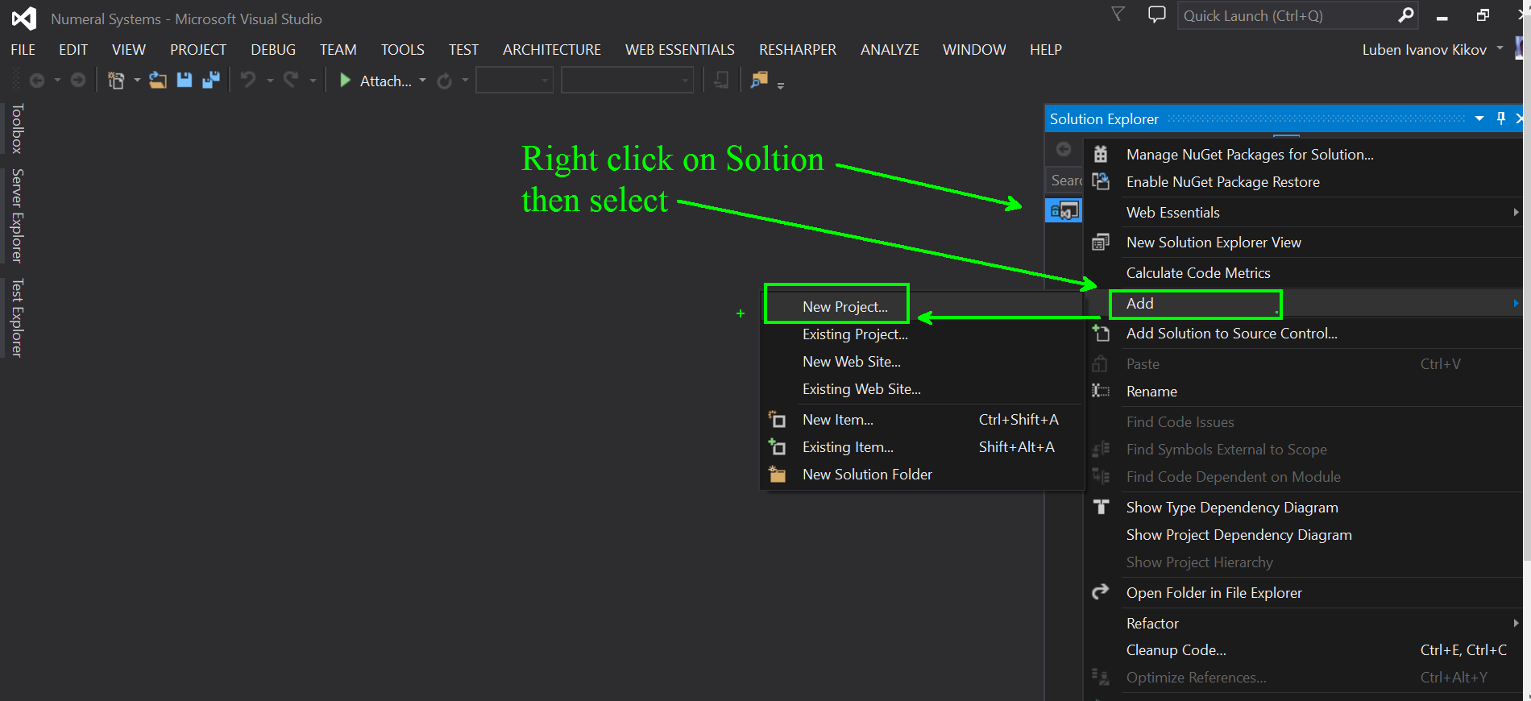

1. 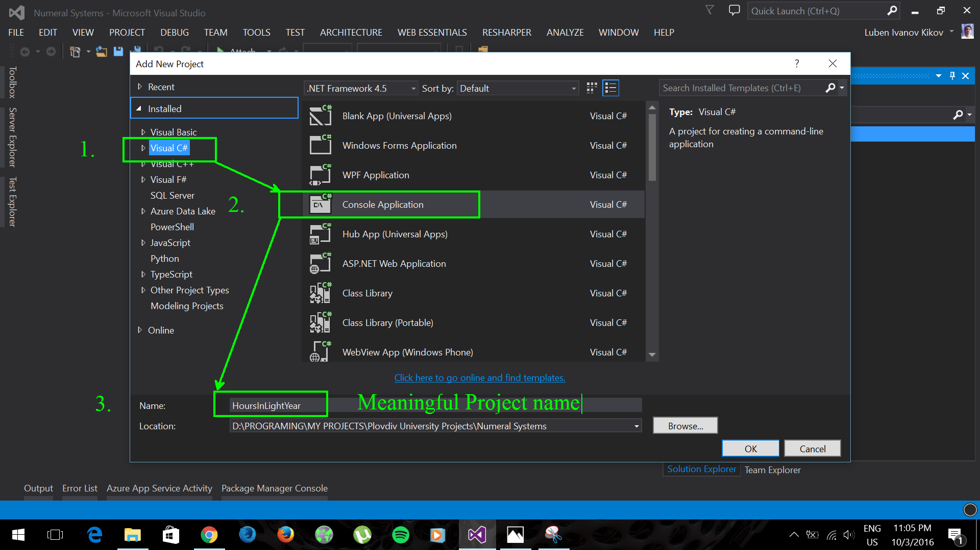The project must be Console App !!!